Task 1 – Database Design (6 Marks)
- Design a complete database for the clinic that includes at least six entities such as Patients, Doctors, Appointments, Treatments, Medicines, Payments, or any other appropriate entities.
- A complete ER/EER diagram.
- Primary and foreign keys.
- Appropriate relationships with cardinality.
- At least one specialization/generalization (EER feature).
- Any assumptions made during the design process.

Assumptions:
- As we are creating a database for a private clinic, so we will need a payment entity.
- Doctor considered as a staff (staff is the superclass entity).
- Each appointment generates exactly one payment bill, and one treatment record.

First: Database Schema:
Entity | Attributes
Patient | patient_id, name (first_name, last_name), date_of_birth, contact_details (phone, email), national_address, gender
Staff | staff_id, name (first_name, last_name), date_of_birth, contact_details (phone, email), national_address
Doctor | specialization, license_number
Receptionist | desk_number, shift_type
Appointment | appointment_id, appointment_date, appointment_time
Treatment | treatment_id, treatment_name, treatment_cost
Medicine | medicine_id, medicine_name, description, unit_price, stock_quantity
Payment | payment_id, payment_date, payment_method, amount

Second: Relationships & Cardinalities:

Relationship | Entities | Cardinality | Description
Is-A Relationship  (Disjoint & Total Participation) | Staff – Doctor, Receptionist | Inheritance / Specialization hierarchy | The doctor inherit the attributes and relations from the staff entity, and the staff must be categorized as either doctor or receptionist, but not both.
Book | Patient - Appointment | 1 : N | A patient can book many appointments, but the appointment is booked for only one patient.
Undertake | Doctor - Appointment | 1 : N | A doctor can have many appointments, but each appointment is undertaken by one doctor.
Produce | Appointment - Treatment | 1 : 1 | Each appointment produces one treatment, and each treatment is linked with one appointment.
Include | Treatment - Medicine | M : N | The treatment could include many medicines, and the medicine could be in many treatments.
Incur | Appointment - Payment | 1 : 1 | Each appointment incurs one payment bill, and each bill is attached to one appointment.

Third: Relational Schema Mapping (Keys, Foreign Keys, Junction Table):
Entity | Attributes (Keys & Foreign Keys)
Patient | patient_id (PK), name (first_name, last_name), date_of_birth, contact_details (phone, email), national_address, gender
Staff | staff_id (PK), name (first_name, last_name), date_of_birth, contact_details (phone, email), national_address
Doctor | doctor_id (PK, FK > Staff.staff_id), specialization, license_number
Receptionist | receptionist_id (PK, FK > Staff.staff_id), desk_number, shift_type
Appointment | appointment_id (PK), appointment_date, appointment_time, patient_id (FK), doctor.staff_id (FK)
Treatment | treatment_id (PK), treatment_name, treatment_cost, appointment_id (FK)
Medicine | medicine_id (PK), medicine_name, description, unit_price, stock_quantity
Payment | payment_id (PK), payment_date, payment_method, amount, appointment_id (FK)
Treatment_ Medicine | treatment_id (PK, FK), medicine_id (PK, FK), quantity, dosage, instructions  Composite PK: treatment_id, medicine_id

Fourth: EER Diagram:
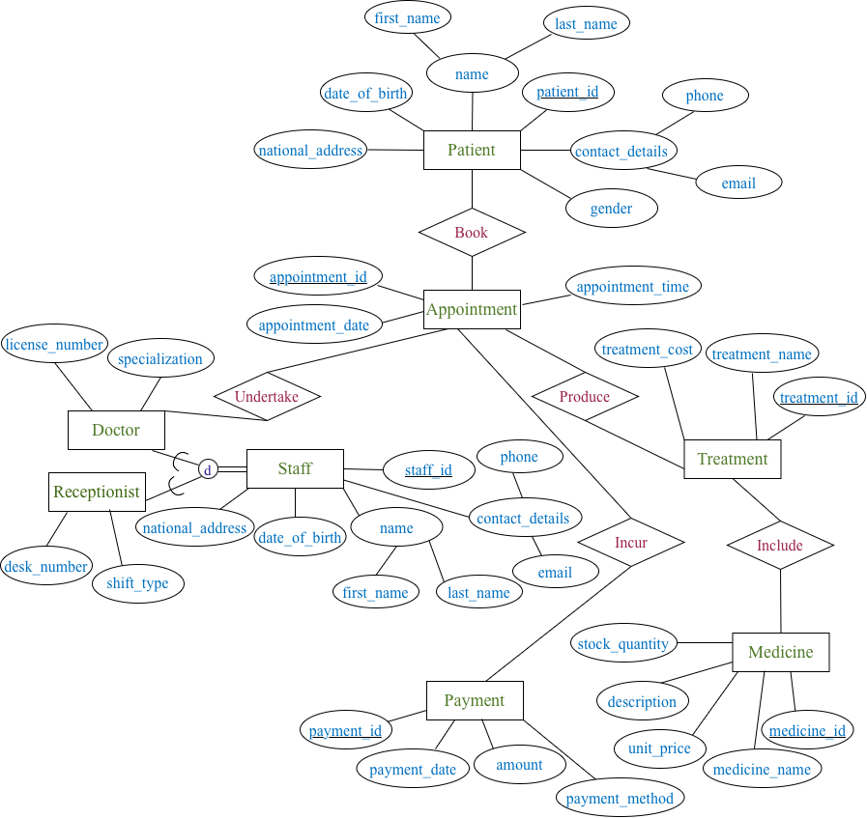
1

N
1
1
N
M
1
1
1
N

